1. **Setting up JUnit (pom.xml)**

<project xmlns="http://maven.apache.org/POM/4.0.0"

xmlns:xsi="http://www.w3.org/2001/XMLSchema-instance"

xsi:schemaLocation="http://maven.apache.org/POM/4.0.0 https://maven.apache.org/xsd/maven-4.0.0.xsd">

<modelVersion>4.0.0</modelVersion>

<groupId>com.example</groupId>

<artifactId>JUnitSetup</artifactId>

<version>0.0.1-SNAPSHOT</version>

<dependencies>

<dependency>

<groupId>junit</groupId>

<artifactId>junit</artifactId>

<version>4.13.2</version>

<scope>test</scope>

</dependency>

</dependencies>

</project>

**Testing:**

import org.junit.Test;

import static org.junit.Assert.*;

public class SampleTest {

@Test

public void testAddition() {

assertEquals(4, 2 + 2);

   }

}

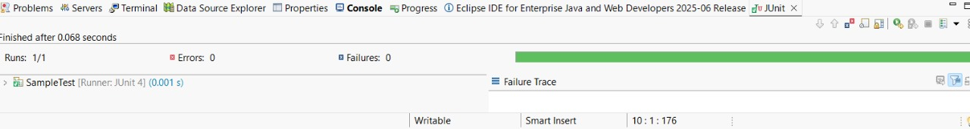

**3.Assertions in JUnit**  
  
package example.calculator;

public class calculator {

public int add(int a,int b)

{

return a+b;

}

public int subtract(int a,int b)

{

return a-b;

}

}

**Testing**

package example.calculator;

import org.junit.Test;

import static org.junit.Assert.*;

public class testcal {

@Test

public void testadd()

{

calculator ob=new calculator();

assertEquals(5,ob.add(3, 2));

}

@Test

public void testsub()

{

calculator ob=new calculator();

assertEquals(1,ob.subtract(3, 2));

}

}

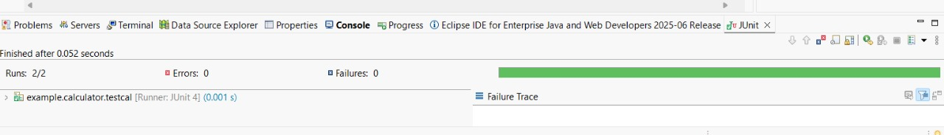

**4. Arranging-Act-Assert (AAA) Pattern, Test Fixtures, Setup and Teardown methods in JUnit**

import org.junit.Test;

import static org.junit.Assert.*;

public class assertiontest {

@Test

public void testassertions()

{

assertEquals(5,2+3);

assertTrue(5>3);

assertFalse(5<3);

Object ob1=null;

assertNull(ob1);

Object ob2=null;

assertNull(ob2);

}

}

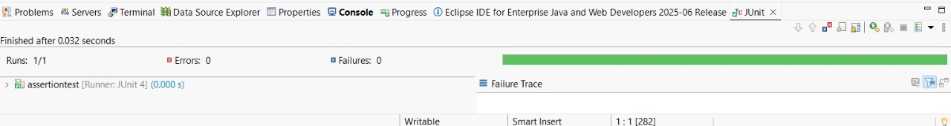

4.

package example.calculator;

import org.junit.*;

import org.junit.Assert.*;

import static org.junit.Assert.assertEquals;

public class setup {

private calculator calc;

@Before

public void setUp() {

System.out.println("Setting up Calculator object");

calc = new calculator();

}

@After

public void tearDown() {

System.out.println("Tearing down");

calc = null;

}

@Test

public void testAdd() {

int result = calc.add(4, 5);

assertEquals(9,result);

}

@Test

public void testSubtract() {

int result = calc.subtract(10, 4);

assertEquals(6, result);

}

}

